Lowe International Business Plan
Name
Institution

Contents
Executive Summary 4
Purpose of Report 4
Methods 4
Findings and Conclusion 4
Recommendation 5
Geographical location 5
Mooresville Map 6
Introduction 6
Visa/passport requirement 7
Climate 7
Housing 8
Means of public and private transportation 8
Banking rules 8
Vaccination and blood tests 8
Exit requirement 9
Marketing Strategy 9
Market Analysis 9
Characteristics of Potential Customers 10
E-Marketing 10
Governance and CSR 12
Value Addition for Competitive Advantage 12
Porter’s Five 13
Competitive rivalry 13
Buyer Power 14
Supplier Power 14
Threat of substitution 14
The threat of new entry 15
Financial Projections 15
Market Share Estimates 15
Revenue Forecasts for the Next Three Years 16
Strategy Implementation 16
Mode of Entry 16
Balanced Scorecard 17
Financial Perspective 17
Customer Perspective 17
Internal Process Perspective 17
Learning and Growth Perspective 17
Conclusion 18
References 20
Appendix 21

Executive Summary

Purpose of Report
Lowe, a retail company, is looking to diversify its products within the field of home improvement products. The identified market is Japan, and the selected product is brick and mortar, these ensures that all the homes are well set and looking smart as per the requirement of the client.
The report’s objectives are:
- Evaluating the viability of the Japan market for the selected home improvement product
- Determine the best way of entering the Japan market

Methods
Data was gathered from various online sources that capture the existing market in Japan, the potential targeted customers, and the level of forces that influence operations. Various statistical and data sites were utilized in developing a clear understanding of how brick and mortar can perform in Japan and the arch that will prove beneficial to Lowe when venturing into the market.

Findings and Conclusion
There is a ready and growing market in Japan shown by the high rates of people in the region who are trying to ensure that their home looks good. The identified population is aware of the present opportunity of using the home improvement product. However, because of changes in lifestyles many people in Japan are making steps in trying to ensure that the place they live is looking best. This creates an opportunity for Lowe to venture into this market with a differentiated product by offering value through collaboration with home care facilities.

Recommendation
Lowe should consider venturing into the market by using the Greenfield venture to understand the market better. Besides, Lowe should invest in developing relationships with home care facilities that will collaborate with the company to increase public education and interaction with the target customers as the most unique feature that will increase the chances of success and competitive advantage in Japan.

Geographical location
Lowe’s companies, Inc. is a retail type of company that is mainly into home improvement product selling. Is located in North Carolina at a place that is known as Mooresville but apart from that it has extended its branches to many parts of the world and it is also operating in both Canada, Mexico and also the United States. With the increase in demand of the bricks and mortar the company is growing and looking for market in japan in an aim of expanding the business to reach many different people across all diversities of life. Among the top 500 fortunes Lowe’s is ranked at position 42 and it is considered the world’s second biggest improvement retail chain. It is composed of both full tie and part time works with an estimate of 200,000 full time workers and 120,000 part time workers across its 1,977 retail stores. The weekly customer’s average is estimated at 18 million and the company mainly operates in a fiscal year starting February 1st to January 31st.

Mooresville Map
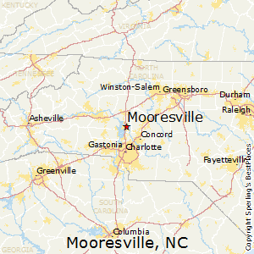

Introduction
Over the last three decades, house maintenance and decoration have been an issue in Japan, and for a long time, it has increased significantly. In 1980, reports recorded that the house maintenance and decoration in Japan were less than 1%, and by 2010 it had risen to 11.6%. Currently, it has reached proportions in most of Japan's population, and thus, Lowe comes in trying to ensure that the issue is solved. The increasing number of people with home issues in Japan is proving to be a burden economy at individual and community levels.
Lowe's companies Inc. gives the best services to improve home products in many parts of Mexico, Canada, and the United States. The organization of Lowe's gives many different products and services for landlords, homeowners, and contractors. They mainly operate under two platforms: the mortar stores and traditional brick, and also they are useful in offering online e-commerce sites. The product falls within the retail trade industry sector 44-45 subsector 446 that encompasses contractors, homeowners, and landlords. The country of focus for the product in Japan. This is because Japan is one of the nations with the highest population count and a high prevalence of people capable of being homeowners, contractors, and landlords. The client is Lowe, a retail organization looking to diversify its products and services into a new market, with Japan being the best option. This report will offer market analysis, the best practices that Lowe should embrace when entering the Japanese market with the new home products and services, and evaluate the potential for success.

Visa/passport requirement
In introducing the products in Japan, there first needs to be a permit allowing the individual to enter a particular country and the reasons for entering the country. Japan accepts foreigners into the country as long as they feel the forms, and Japan's government verifies them. The mandatory requirement for a stay in japan includes a valid passport and a visa requiring someone to enter the country and do business. Once in the country, there are also permits that must be acquired if someone wants to start a business, and the company must follow all the set rules and regulations of the country. Lowe's company must present themselves well and follow the countries rules and regulations to avoid being thrown out.

Climate
Japan is among the countries with four seasons, which are different throughout the year, and the climate ranges typically from subtropical in the south to subarctic in the north. The conditions are also different between the side of the Japan Sea and the side of the Pacific. Most parts of Northern Japan are mainly warm during summer, and during winter, the weather is freezing with heavy snow on the Japan sea side and is freezing in areas that have mountains.

Housing
Housing in Japan mainly involves houses that are traditional and modern made styles. The houses are affordable because there are mainly two kinds of houses, such as a simple house made of wood-framed that is costing an average of 200,000 Yen/sqm to build. There are also houses mainly reinforced by concrete, and they roughly cost 450,000 Yen/sqm and up. The prices will differ depending on the finishing and the design of the house.

Means of public and private transportation
Transportation in Japan is very much developed there are private and public means of transport. People mainly use buses as a form of transport from one area to another. Apart from buses, there is also railways transport that helps in transporting people. In addition to the two, there is also subway transport. The private transport mode also includes cubs that are hired by people who want to move around Japan. Therefore as Lowe thinks of expanding their business, they should also consider transportation.

Banking rules
Japan banks are mainly supervised by a financial services agency that makes sure that all the banks in the country are well maintained and operating according to the terms set. There are working hours that the bank is supposed to operate after which no services will be offered. The ATMs are mainly operating on a 24 hours basis, and thus it is easy for the people to withdraw money at any given time.

Vaccination and blood tests
Japan will only allow those who are healthy without any issues to move into their country. Several tests will be carried out to determine if the person is okay. The tests include the high blood pressure test, HIV test, and test on any disease.

Exit requirement
Just as entry into Japan, the passport and visa are also needed, and they should all be valid as per the date of acquiring them. The passport must also be valid for all the period spends in Japan.

Marketing Strategy

Market Analysis
According to the World Population Review (2020), Japan is ranked among the countries with the world's highest population density. The country's current population is 126,364,241, as per the United Nations' projection of data. It is estimated that the number will continue to rise for the foreseeable future until 2030 before it gradually begins to decline. One of the sectors showing significant promise is the real estate sector as it is increasing. The reasons behind this rapid growth include urbanization, the aging population, technological innovation, and a constant increase in wages and living standards.
Further studies show that per capita real estate expenditure in Japan has significantly increased in recent years, highlighted with growth from $42 in 2000 to $398 (White, 2015). However, this has considerably remained low regarding GDP per capita, which is at 4.9% compared to the United States, which read at 17% in 2017 (White, 2015). Regardless, the country's total real estate spending remains high, which was recorded at $547 billion. Various factors have been at play and sustain the continuous growth of the real estate sector in Japan. These include enhanced real estate technology and the public's awareness of real estate matters triggering a growing demand for quality real estate services. Besides, as the country's population grows, it highlights an increasing need for real estate products and services for many homeowners.

Characteristics of Potential Customers
Before venturing into a new market, an organization must develop a clear picture of their potential clients. This plays a crucial role in defining and developing a product that will meet their needs with ease. Identifying potential customers entails dividing the market into geography, demographics, psychographics, behavior, and benefits. Geographically, a considerable number of people in Japan live in urban regions, which translates to the fact that the most significant portion of the targeted customers is in urban areas. Besides, most of the substantial and high-performing real estate facilities are in urban regions, explaining the multi-scalar unevenness of real estate in the country (Darja Kobal Grum & Bojan Grum, 2014).
Real estate is a great way that plays a role in ensuring that people are living in comfortable homes without any challenges. It targets people who are trying to make their place without success. Lowes comes to the rescue in helping most people in Japan live in good houses. Studies set it clear that housing in japan is the main challenge to most people in Japan who are from the age of 20 and 39. The same studies show that approximately 50% of adults in Japan can live a good life, while the remaining 50% struggle to make ends meet.
Lifestyle, part of psychographics, plays a crucial role in determining the number of home owners in a population. The study also recorded that a sedentary lifestyle triggers most of Japan's homeless cases and changes in employment patterns. Many people in urban regions are taking jobs that reduce their physical activity levels. Thus they end up not making homes for themselves; they spend most of their lives living in rental houses without thinking of making a step towards building their place.

E-Marketing
Marketing is an essential part of creating a brand or product awareness in the desired market, as Lowe is looking to venture into a new market. The targeted audiences have already been identified, and these are mostly urban-dwelling individuals between the ages of 20 and 59. However, given that this is a real estate, the marketing strategy must always look at ways of incorporating homeowners as they will advise the targeted market accordingly. Therefore, in Lowe's context, the organization must consider how to use the available technology and social media platforms to promote the real estate while creating access to quality home facilities.
One of the best platforms that Lowe can utilize is corporate websites. Many real estate and home improvement organizations have websites that they use in communicating with both present and potential clients. Lowe should develop an agreement with the home facilities to market brick and mortar among their clients' products. Other than that, many Japanese people rely on blogs as their source of information on issues affecting their daily lives. Lowe will have to pay some of the most influential and real estate related bloggers to communicate with the targeted population on the benefits and essentiality of having brick and mortar in promoting quality lifestyle and better housing.
The most effective e-marketing strategy that Lowe must consider in marketing the home improvement products are on the social media platforms. These are powerful tools for reaching and interacting with an identified market. Every successful organization today understands that social media is the medium for developing close relationships with the client as it facilitates prompt and continuous interaction. Social media marketing entails creating content and sharing content on social media platforms that defined customers use most. Various benefits have been attributed to social media marketing. These include enhanced website traffic, raising brand awareness, creating conversations, and improving communication and interactions with the key audiences. The standard social medial platforms are Twitter, Facebook, and Instagram. Studies show that in 2019 alone, there were approximately 150 million social media platforms in Japan, with the leading platforms being Tencent WeChat and Weibo. There is a growing number of Japanese using social media, and this also shows the potential market growth with the right and effective social media marketing. This represents a potential market with the right social media marketing can become Lowe clients.

Governance and CSR

Value Addition for Competitive Advantage
A company usually positions itself by leveraging its strengths. One of the arguments often presented in value addition is that a company's strength can fall into two fundamental types of competitive advantage: cost advantage or differentiation. Every business goes into a market by looking at how it can meet the demands of the stockholders. This is not the most sustainable idea when consideration being competitive and achieve a competitive advantage. Various companies are competing for a continuously shrinking market based on the number of products competing for consumer attention and loyalty. Though Japan is a big market, it is also fickle because of the number of started regularly and competition within the same industry. Therefore, Lowe must consider adding value to the shareholder while determining what is best in the long-run for the company in the new market. It means Lowe must integrate the approaches of cost advantage and differentiation (Husted & David Bruce Allen, 2011).
Cost advantage considers producing products and services at a lower cost than the competitors. The best way that Lowe can achieve this is by establishing a construction company in Japan. The strategy will cut down the cost associated with an extensive supply chain and importation cost involved. In turn, this will make the brick and mortar cheaper and affordable to the consumers. On the other hand, differentiation considers the unique value that the product or service offers to the consumers that they cannot find among the competitors. It is this that encompasses the maximization of shareholder value. Lowe will have to develop unique ways that meet the consumers' needs, those that they identify and that they have not realized yet. The company will need to continuously invest in research and development to determine what the competitors are offering and the values missing identified from the shareholders' perspective.
The company should also focus on looking into the market and coming up with ways to favor people's needs and pockets in Japan. This can be done by ensuring that the services and products are different from the others offered in the market. The value addition should create a communication medium that allows consumers to interact with homeowners and landlords. This will reduce the cost of construction associated with frequent rising costs and demand. Therefore, the brick and mortar should benefit both the consumer population and real estate institutions (Husted & David Bruce Allen, 2011).

Porter’s Five
Porter's five forces are a strategic tool that allows an organization to understand an industry's economy, hence enhancing its knowledge of the competitive forces within an industry. The five details discussed in Lowe's context are competitive rivalry, buyer power, supplier power, the threat of substitution, and the threat of new entry.

Competitive rivalry
Competitive rivalry assesses the number and strength of the competitors. There are already key players in the Japanese market who are into real estate, and the market is currently valued at the US $78.2 million (Markman & Hin, 2011). Some of the companies already real estate and home improvement products identified in the market include Hachise Company, Hokkaido, Savills, and Anabuki housing company limited. This indicates that the industry is very competitive because many companies of the same size are focusing on the same product, which lowers the switching cost of the users.

Buyer Power
Buyer power evaluates how it is easy for the consumers to drive the products' prices down and influence the quality of the products and services. Japan has a big population, and the targeted market is about 200 million individuals falling between the ages of 16 and 59. However, the presence of many competitors influences the power that the consumers hold in the industry. Therefore, buyers' bargaining power is high, as there are many options. Nonetheless, the company's added value, working with real estate facilities and systems, will leverage this power and increase the switching costs involved. By registering with the real estate systems under which the users are registered, it will be costly for the users to abandon their care plans associated with Lowe's.

Supplier Power
Suppliers are a crucial part of the supply chain, and they can affect the prices of the products and their performance in the market. Japan is among the most competitive countries when considering the internal business environment. It means that many suppliers are continuously competing for the available market. The number of suppliers is higher than the entities purchasing the materials because of the extensive construction industry. Therefore, it translates to the fact that the supplier power is low, and they cannot have significant control over the cost of materials used in real estate making.

Threat of substitution
The threat of substitution is a component of Porter's five forces determining the probability of customers selecting another product over what Lowe offers. The risk of substitution is medium because of two main reasons. First, there is high competition, which increases the targeted audience's chances of switching to real estate if they do not find significant value in what Lowe offers them. However, because of the additional cost attached to Lowe's brick and mortar, customers will enjoy the privileges of purchasing its products and increase the chances of consumer loyalty.

The threat of new entry
A company's position can be affected by the ability of new companies entering the same market. Japan is often known as one of the most competitive markets because of the number of companies that continuously start competing with the existing ones by benchmarking on the established businesses. It is easy for new competitors to gain entry into this industry, which can affect Lowe's market share. However, it is estimated that as the Japanese population continues to increase, so are the demands for brick and mortar and improvement products in the coming years.

Financial Projections

Market Share Estimates
Company share estimates are useful strategies for determining how competitive it will be in a given market. The number of potential customers in the identified market is approximately 200 million, and thus this will be used as the base value of the existing clients. However, not everyone in this population will purchase the products or the services offered, so it is essential to adjust this base value to acquire a more accurate estimate. In 2019, only 120 million people were capable of purchasing the brick and mortar and improvement products and services (Wenzel, 2012). Considering this, Lowe targets people with an interest in real estate and individuals who think they cannot afford the brick and mortar services. Therefore, the estimated people who will highly likely purchase brick and mortar products are a sixth of the general population between 16 to 59 years, which makes it 16.67%.
The estimated market share = 0.167 * 200 million = 33,400,000 customers.

Revenue Forecasts for the Next Three Years
Revenue forecast for the next three years will assume that the number of customers will triple by three by the end of the suggested period (Danninger, 2005).
33,400,000 * 3 = 100,200,000
The present price of brick and mortar in Japan is on average $400
Therefore, the revenue for the next three years $400 * 100,200,000 = $ 40,080,000,000

Strategy Implementation

Mode of Entry
There are various modes of entry that Lowe can consider when venturing into this new market, and these include exporting, licensing, forming partnerships, acquiring an existing company, and Greenfield venture entailing launching a modern, wholly-owned subsidiary. The best option that will allow the company to have total control of the real estate in the Japanese market while continuously having in-depth knowledge is the Greenfield venture (Verweire, 2014).
The Japanese market is complex and needs the company's active participation to gain a competitive advantage. It then demands having in-depth knowledge of the market and control over the processes in the supply chain. The best entry model that Lowe can apply to achieve this is establishing its subsidiary in Japan. Lowe will need to acquire knowledge and expertise in the foreign market, hence calling for significant investment in the company's research and development department. This means gathering data on consumers' ideas of real estate and home improvement, their preferences to determine the opportunity for customization, the features of the country's real estate system, and any factor that may affect the organization's new subsidiary. Nonetheless, Lowe will need to consider establishing a new subsidiary in a foreign market is complicated and expensive. The high costs are associated with building the firm, managing unknown risks, and extensive marketing required to gain market industry (Parker & Mirjam Van Praag, 2006).

Balanced Scorecard

Financial Perspective
This segment's objective entails establishing a baseline of sales that will cover the cost of establishing the new subsidiary in the new market. This will be indicated by making a 10% profit from both sales and services.

Customer Perspective
Lowe is focused on adding value to the shareholders, and this means that one of the objectives should be customer-driven. The objective thus is to have more unique and customizable brick and mortar services that increases customer satisfaction. Hence, the goal will be to increase purchase by 10% every month. This will be measured by the number of purchases made by the customers (Hannabarger, Buchman, & Economy, 2007).

Internal Process Perspective
Internal processes often affect the way the organization interacts with the external environment. The main objective of the internal processes is the increased productivity of the employees. Increased productivity will be indicated by increased customer fulfilment and the production of quality materials.

Learning and Growth Perspective
This viewpoint focuses on the skills and capacities needed to sustain valued and quality processes. Therefore, learning and growth perspective is concerned with the jobs, system, and internal climate of the organization. Lowe’s objective in this perspective is having skilled employees and an effective business analytics system. The goals will be to set up a training department that focuses on individual enhancing individual and group skills.

Lowe’s vision is providing customer-valued solutions with the best prices, products and a service to make Lowe’s the first choice for brick and mortar and home improvement.
 | Objectives | Goals | Indicators | Initiatives
Financial perspective | Setting baseline sales | Making 10% profits | Financial statements | Strong marketing approaches
Customer perspective | Sell unique and customizable brick and mortar products | Increase purchase by 10% monthly | Increased customer base | Create innovative committee
Internal process perspective | Increasing employee productivity | Increase production out by 5% | % monthly sales | Establish systems that increase employee satisfaction
Learning and growth perspective | Have skilled employees and effective business analytics | Create an effective training department | Reduced errors and increased customer satisfaction | Improve real estate systems.

Conclusion
Lowe’s is a company that offers a variety of services when it comes to home improvement services. The kind of services and the product that they offer will, in a significant way, help in catering to the rising needs of the customers. In Japan, many people are suffering from brick and mortar and home improvement services due to high prices and lack of advice on how people should go about their issues. In trying to solve the problem, Lowe has made a step in making it easier for the people to manage and acquire their homes and also making their homes attractive at an affordable price. With many people in demand of real estate advice and services, Lowe will, in a significant way, play a role in ensuring that the people are satisfied, and in doing this, it will increase the number of customers moving into the organization and seeking help. Also, in helping beat the growing market competition, the organization has taken into account research and looking for the market standards and the pricing of different companies in trying to help the people out with affordable prices. It is also clear that the company should ensure that they evolve their value chain through modifications and constant evaluations. For any successful strategy, it is evident that value change is essential, and it is considered a foundation for a competitive system. Lowe has chosen as their vision statement, “We will provide customer-valued solutions with the best prices, products and a service to make Lowe’s the first choice for home improvement.” Lowe’s vision statement makes it abundantly clear that enhancing their value chain is the only way to fulfill their vision.
Currently, the Japanese market already has manufacturing and selling the same product since it has been identified as a lucrative industry with significant growth potential. Despite the market already having numerous competitors, Lowe should focus on offering unique products by collaborating with real estate institutions to help the people access assistance whenever necessary. This is the unique value proposition that Lowe should concentrate on increasing its competitiveness in the market and ensure success. The best market entry approach that Lowe should utilize is launching a new, wholly-owned subsidiary. Though this may be costly and complex, it will offer Lowe full understanding and control over the market.

References
Danninger, S. (2005). Revenue forecasts as performance targets. Washington, Dc Internat. Monetary Fund.
Darja Kobal Grum, & Bojan Grum. (2014). Psychological characteristics and expectations of potential real estate buyers. Istanbul: The International Institute For Academic Development.
Hannabarger, C., Buchman, R., & Economy, P. (2007). Balanced Scorecard Strategy for Dummies. Hoboken: John Wiley And Sons.
Husted, B., & David Bruce Allen. (2011). Corporate social strategy : stakeholder engagement and competitive advantage. Cambridge, Uk ; New York: Cambridge University Press.
Markman, G. D., & Hin, P. (2011). Competitive dynamics of entrepreneurial market entry. Cheltenham, Glos, Uk ; Northampton, Ma: Edward Elgar.
Parker, S. C., & Mirjam Van Praag. (2006). The entrepreneur’s mode of entry: business takeover or new venture start? Amsterdam Etc.: Tinbergen Institute.
Verweire, K. (2014). Strategy implementation. Abingdon, Oxon: Routledge.
Wenzel, A. M. (2012). The entrepreneur’s guide to market research. Santa Barbara, Calif.: Praeger.
White, P. (2015). MARKET ANALYSIS : its principles and methods (classic reprint). S.L.: Forgotten Books.

‌

‌

‌
‌

Appendix
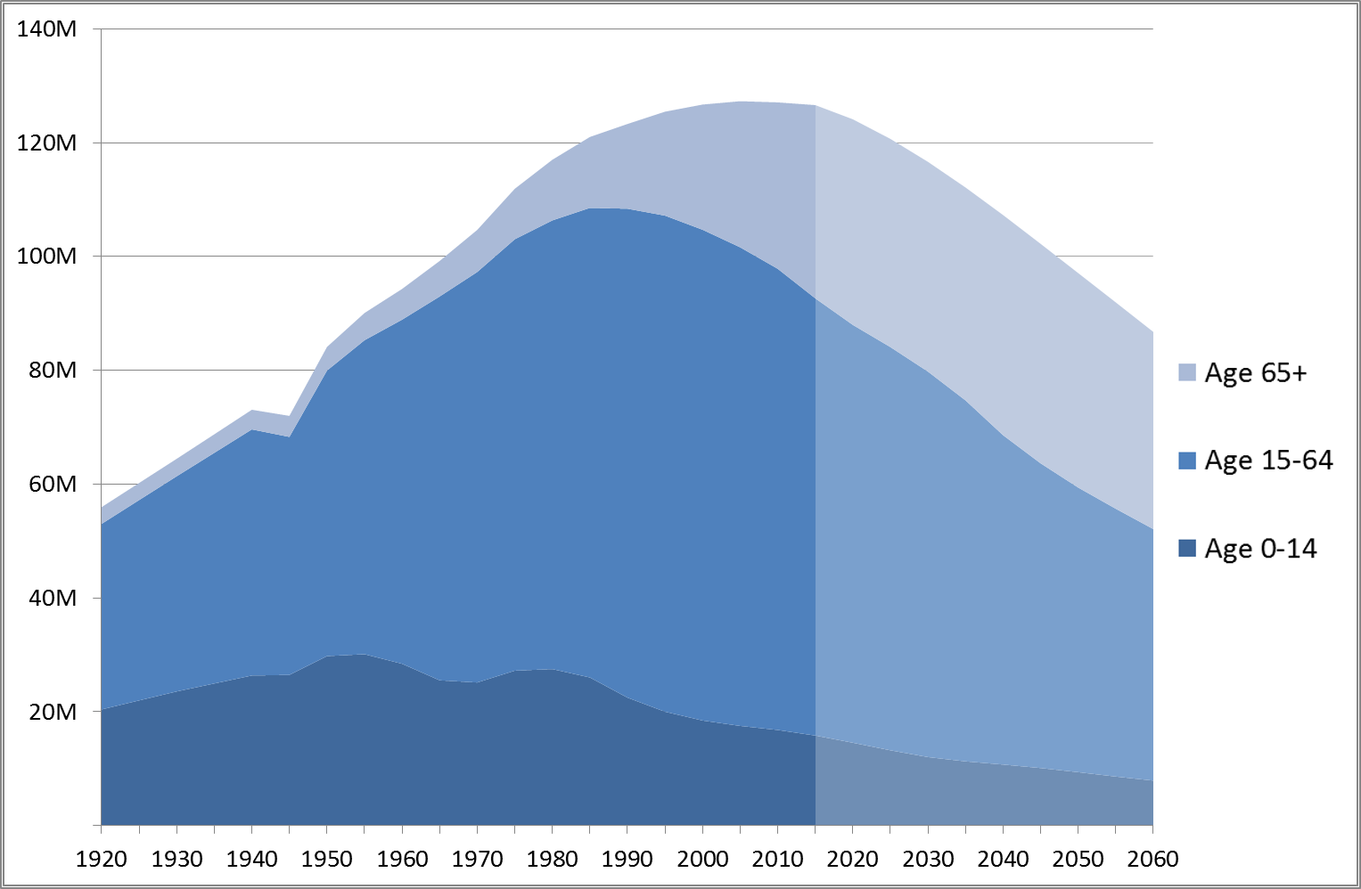
Figure 1: Japan Population
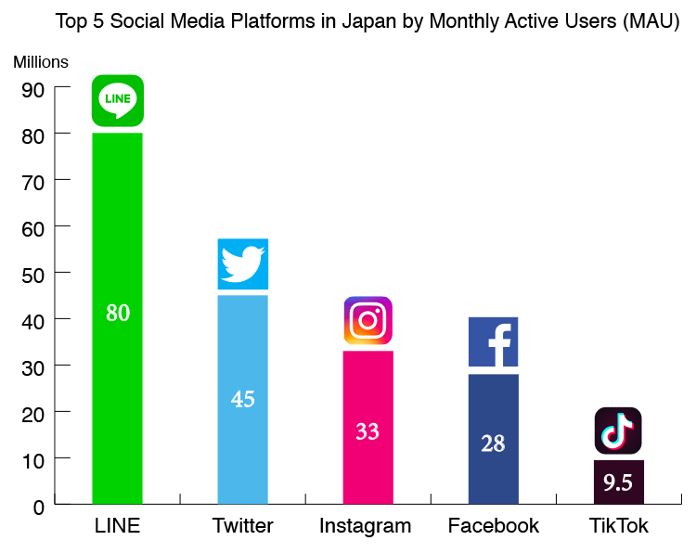
Figure 2: Social Media Users in Japan

